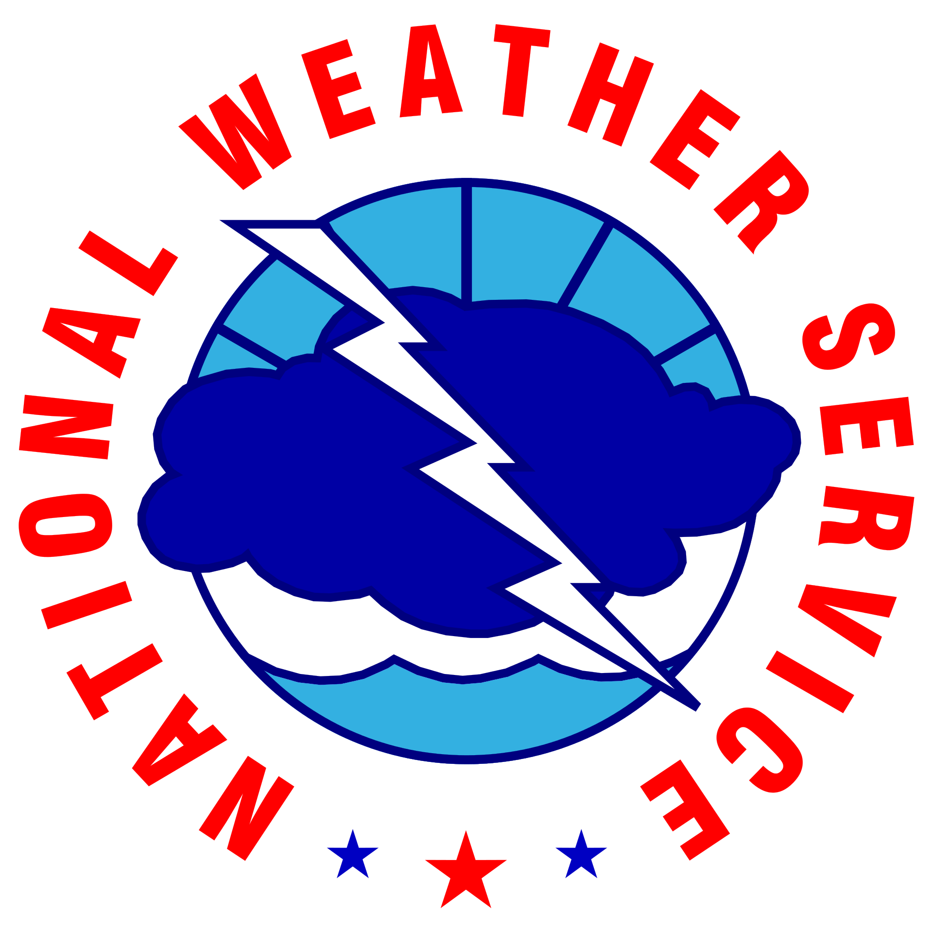
NOAA/NWS Lightning Toolkit

OUTDOOR VENUE
LIGHTNING SAFETY, ENTER ORG. NAME

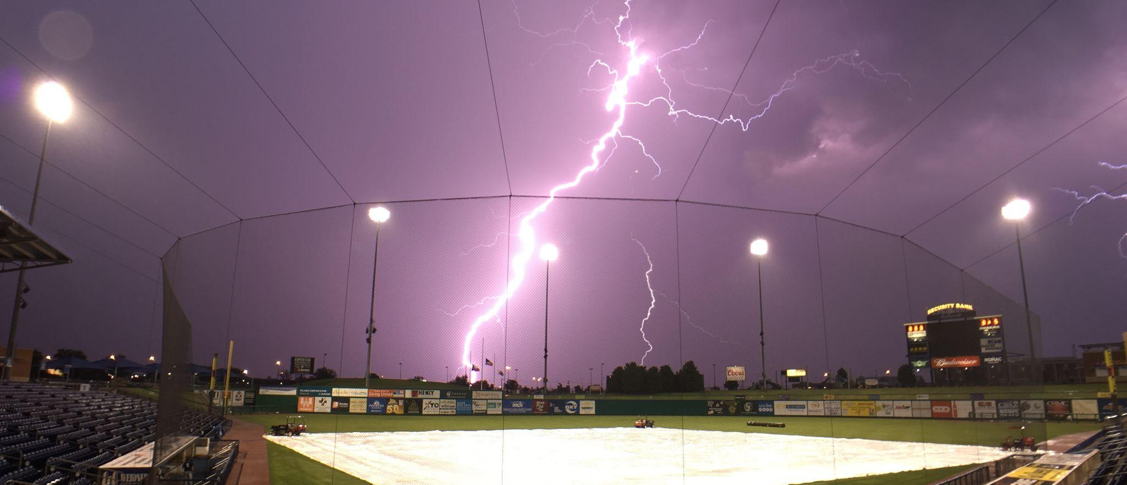

Why This Matters
The National Weather Service (NWS) has implemented a voluntary recognition program to help large outdoor venues, including those on university campuses, better protect staff and patrons from the dangers of lightning. Eligible sites include outdoor sporting arenas, concert venues, water parks, raceways, and amusement parks.
This program is designed to help reduce the risk of lightning related threats through improved preparedness on the part of facility and event staff and emergency managers. It is also designed to increase public awareness of the hazards associated with thunderstorms and lightning. University emergency managers are encouraged to utilize the lightning safety toolkit to develop a lightning safety plan. Those who complete the process will be recognized for their proactive efforts in lightning safety.
The National Weather Service is committed to raising lightning safety awareness.

Protect Your Staff & Patrons From Lightning Dangers
The NWS recognizes the efforts of outdoor venues that follow these guidelines to protect staff and patrons from the dangers of lightning. These guidelines may be satisfied by incorporating data/services provided by America's Weather Industry:
- Information Reception: The venue must install a locally-run lightning detection system with a display unit on site or subscribe to a commercial notification system. The facility must also have continuous access to information about NWS warnings during public events.
- Decision Support Standards: The venue must have a written lightning safety plan that includes written instructions on how to contact local emergency management and a weather service provider (e.g., provider from America’s Weather Industry or NWS).
- Public Notification Plan: The venue must have several means to notify its patrons that a lightning threat exists. Options include outdoor warning sirens, a public address system, internal television/radio broadcast, text/email message alerts, use of social media, and staff announcements.
- Protection Program: The venue must have means to shelter patrons. This would include providing direction to substantial lightning-safe structures or access to vehicles, a written emergency operations safety plan to evacuate the venue, and signs indicating where shelters are located. The venue should investigate lightning protection equipment that intercepts lightning and diverts the discharge away from patrons and staff.
- Education: The NWS can provide lightning safety education materials. The venue should ensure it informs patrons of lightning precautions it has taken and the actions patrons should take when notified of a lightning threat.
For more information on NWS support for special events, visit: https://www.weather.gov/media/stormready/resources/specialevents.pdf
To find out more about this program, contact Charlie Woodrum at: charles.woodrum@noaa.gov

Lightning Safety Plan for (enter org. name)

Before the Event
Name of Weather Watcher will ensure a weather situational awareness plan¹ is in place the day before and the day of the scheduled event. Staff will monitor the local weather via three or more of the following services: television news coverage, the Internet, mobile devices, cable and satellite weather programming, commercial services, NOAA weather radio, and National Weather Service (NWS) forecasts.
NWS Advisories, Watches, Warnings and Hazardous Weather Outlooks (HWO) can be monitored at https://weather.gov/Click to finish office link. (Links to all NWS offices) Thunderstorms and severe weather forecasts also are online at http://www.spc.noaa.gov .
If thunderstorms are forecast for the day of the event, officials will review the safety plan before the event and identify the responsible officials and chain of command to implement the safety plan. Specifically, officials will designate a weather watcher for the event who will notify officials of the status of any thunderstorm that may threaten the safety of the event.

Public Information
If thunderstorms are in the forecast, officials will notify patrons via the Click or tap here to enter text and over the public address system at the venue prior to the event beginning. Lightning safety guidelines and evacuation procedures will be printed in event programs.

¹ Situational Awareness Example: Site has a computer with internet access designated for monitoring local weather web sites. A television is tuned to a channel dedicated to weather. A lightning detection system display unit is tested to ensure it is operable prior to the event. All weather reception and communication methods are tested to ensure functionality.

Before the Event (Cont.)

Designated Lightning-Safe Structure(s) or Vehicles
- Click or tap here to enter text.
- Click or tap here to enter text.
- Click or tap here to enter text.
- Click or tap here to enter text.
- Click or tap here to enter text.
If a substantial building is not available, enclosed motor vehicles can provide shelter as long as patrons do not touch the metal framework during the thunderstorm.
No place outside is safe if lightning is in the vicinity. Partially enclosed vending areas and picnic shelters are not safe. If no safe structure is available, direct patrons to stay away from the tallest objects (trees, light poles, flag poles), metal objects (fences or bleachers), standing pools of water, and open fields. If patrons are still in transit to the venue, encourage them to remain in their vehicles until the lightning threat has ended.

During the Event
The weather watcher will use weather monitoring and lightning detection tools along with local observations² to help determine the proximity of lightning and which safety actions to implement. The direction and speed of an approaching thunderstorm should be accounted for along with locally developing storms that may form nearby or overhead. If lightning (cloud-to-cloud or cloud-to-ground) is in the vicinity, the following procedures are recommended.
Please note: Lightning radii will vary based on venue size, capacity, and the amount of time it takes patrons to get to safe structures. Distances can be modified as local emergency management deems appropriate.

When lightning is detected within 15 (click to edit) miles of the venue:
- Weather watcher notifies management of elevated lightning monitoring. Management notifies the event officials.
- Venue management notifies all staff members of the potential for a delay. Designated staff members are stationed to direct patrons to safe structures.
- An evacuation of the facility will begin if it appears the thunderstorm is moving toward the venue. If a more organized thunderstorm or cluster of thunderstorms (supercells, squall lines, bow echoes) are headed for the venue, a 30 minute lead-time or more should be considered for an evacuation. These are the major impacting events with high lightning counts where an advanced delay or postponement of the event is justified. (see PA system evacuation announcements). In these cases, the weather watcher or lightning detection system operator should estimate the speed and direction of the storm movement to determine when they will enter a(n) 8 (click to edit) mile radius of the venue.

Continued, next page

² Without technology available, the best method for local observations to determine if lightning is within an unsafe range is to listen for thunder, watch for lightning, and remember that “When Thunder Roars, Go Indoors!”

During the Event (Cont.)

When lightning is detected within 12 (click to edit) miles of the venue:
- Weather watcher notifies venue management of the impending lightning threat. Management notifies the event officials.
- Venue management informs all event staff of an impending delay. Staff members are stationed to direct the crowd to safe structures.
- If there is high confidence that lightning will move within the designated minimum radius, evacuations of the facility can begin early at this distance if not already initiated. If more organized thunderstorms (supercells, squall lines, and bow echoes) are headed for the venue, an evacuation is necessary. (see PA system evacuation announcements)

When lightning is detected within 8 (click to edit) miles of the venue:
- An event delay is implemented when the weather watcher notifies venue management of a nearby lightning threat and, if applicable, the facility warning signal is activated. Management notifies the event officials. Event officials suspend activities.
- Venue management informs all event staff that the event has been suspended due to lightning in the area. Staff members are positioned to direct the crowd to safe structures.
- An evacuation of the venue begins (see PA system evacuation announcements).
- All patrons are directed to the nearest lightning-safe structure (see designated shelters).
- All event performers and officials will be evacuated to pre-designated safe structures.

During the Event (Cont.)
Watches & Warnings

If a Severe Thunderstorm or Tornado Watch is in effect:
A watch indicates that conditions are favorable for severe weather to develop. The weather watcher will communicate this information to the venue management, indicating that elevated thunderstorm monitoring is occurring. Vital information to be shared will include the threats with the watch and the time that it is in effect until.

If a Severe Thunderstorm or Tornado Warning is in effect:
A warning means that severe weather has been detected and may be imminent in the locale. The weather watcher will communicate this information to the venue management, indicating that the thunderstorm may be imminent. Vital information to be shared will include the threats with the storms and the time that the warning is in effect until. If the threat is imminent, an evacuation of the venue will take place.

The weather watcher will keep a log of information briefed and actions taken as a result of updates. If the watcher has questions about a storm, they can contact a commercial weather service provider at Click to add phone number .
The NWS is especially concerned that you are prepared for hazardous weather, and will want to talk with your service provider from America’s Weather Industry well before the event. Your service provider can contact the local NWS office at Click to add phone number.

During the Event (Cont.)
Public Address System Evacuation Announcements
In a case where thunderstorms are in the forecast and an evacuation is possible during the event, radio, public address system announcements, and visual display boards will state:
“Inclement weather, including lightning, is forecast today and may lead to the suspension of play. Those of you who wish to leave the venue for a safe structure or vehicle will be permitted to re-enter with your ticket stub.”
In the case of an evacuation, radio, public address system announcements, and visual display boards will state:
“Inclement weather, including lightning, is in the area. The event has been suspended until the weather no longer poses a danger to this area. Please begin to evacuate in a calm and orderly fashion for everyone’s safety. Once the storm clears, we will notify patrons of the resumption of the event. At that point, you will be permitted to re-enter with your ticket stub and return to your seats.

Resuming the Event
- If the venue is consulting with a professional meteorologist that is using real-time lightning cloud-to-cloud and cloud-to-ground data, the event may resume only if all of the following conditions are met:
  - Lightning has moved beyond 8 miles of the venue.
  - The storm motion is taking the lightning activity away from the venue.
  - The threat of new lightning strikes within 8 miles of the venue has ended.
- If the venue is not consulting with a professional meteorologist that is using real-time lightning data, the venue will wait 30 minutes after no observed thunder or lightning during the day or thunder at night before resuming activities.

After the Event
The weather watcher will remain on duty until post-event operations come to an end. A review of the weather’s impact on event operations and the effectiveness of the safety plan will occur between the weather watcher and venue management.

Venue Contacts
The venue management should have written instructions on how to contact local emergency management and the National Weather Service for information relative to the safety of their patrons.
National Weather Service Contact | Click or tap here to enter text.
Emergency Management Contact | Click or tap here to enter text.
Police Contact | Click or tap here to enter text.
Fire Contact | Click or tap here to enter text.
Event Staff Contact | Click or tap here to enter text.

Venue Preparation Checklists

Data Reception Sources
The venue should investigate the installation of a locally run lightning detection system with a display unit on site or subscribe to a lightning detection and commercial notification system. In addition, the facility should have a NOAA weather radio on location.
☐ Lightning Detection System: Click or tap here to enter service name.
☐ Commercial Lightning Detection Network: Click or tap here to enter provider.
☐ Mobile device
☐ Internet (subscription for alerts): Click or tap here to enter provider.
☐ NOAA Weather Radio (NWR)
☐ Television (Local network or Cable TV)
☐ Radio Station (AM/FM) - EAS Reception
☐ Amateur Radio
☐ Other: Click or tap here to enter text.

Protection Program
The venue should have means to shelter and protect its patrons. This would include a written emergency operations safety plan for evacuation of a stadium, signs indicating where safe structures are located, substantial structures on venue property (e.g. golf courses could use restrooms and club house facilities which are easily accessible from a majority of the course). Also, the venue should investigate lightning protection equipment that intercepts lightning and diverts the discharge away from patrons and staff.
☐ Lightning Rods Installed
☐ Primary Shelters Designated and Marked
☐ Secondary Shelters Designated and Marked
☐ Weather Evacuation Signs Posted
☐ Other: Click or tap here to enter text.

Venue Preparation Checklists (Cont.)

Public Notification Plan
The venue should have several means to notify its patrons if a lightning threat exists. This could include a public address system, internal television/radio broadcast, text/email message alerts, use of social media, and announcements from event staff.
☐ Public Address Announcements
☐ Video Board Message Developed
☐ Outdoor Warning Voice Cable Siren(s)
☐ Venue TV Override
☐ Telephone Tree to Event Staff
☐ Local Alert Broadcast System
☐ Local Pager System (dissemination)
☐ Local Radio Broadcast (dissemination)
☐ Text/email message alerts
☐ Social Media
☐ Other: Click or tap here to enter text.

Education
Lightning safety materials from the National Weather Service are available for interested venues. Venues should ensure that guests are made aware of lightning safety precautions that the venue has taken and the actions which patrons should make when notified of a lightning threat
☐ Venue Staff Safety Training
☐ Event Lightning Safety Day
☐ Safety Page in Program
☐ Public Address Announcement
☐ Plans coordinated with Fire, EMS, and Police
☐ Other: Click or tap here to enter text.

