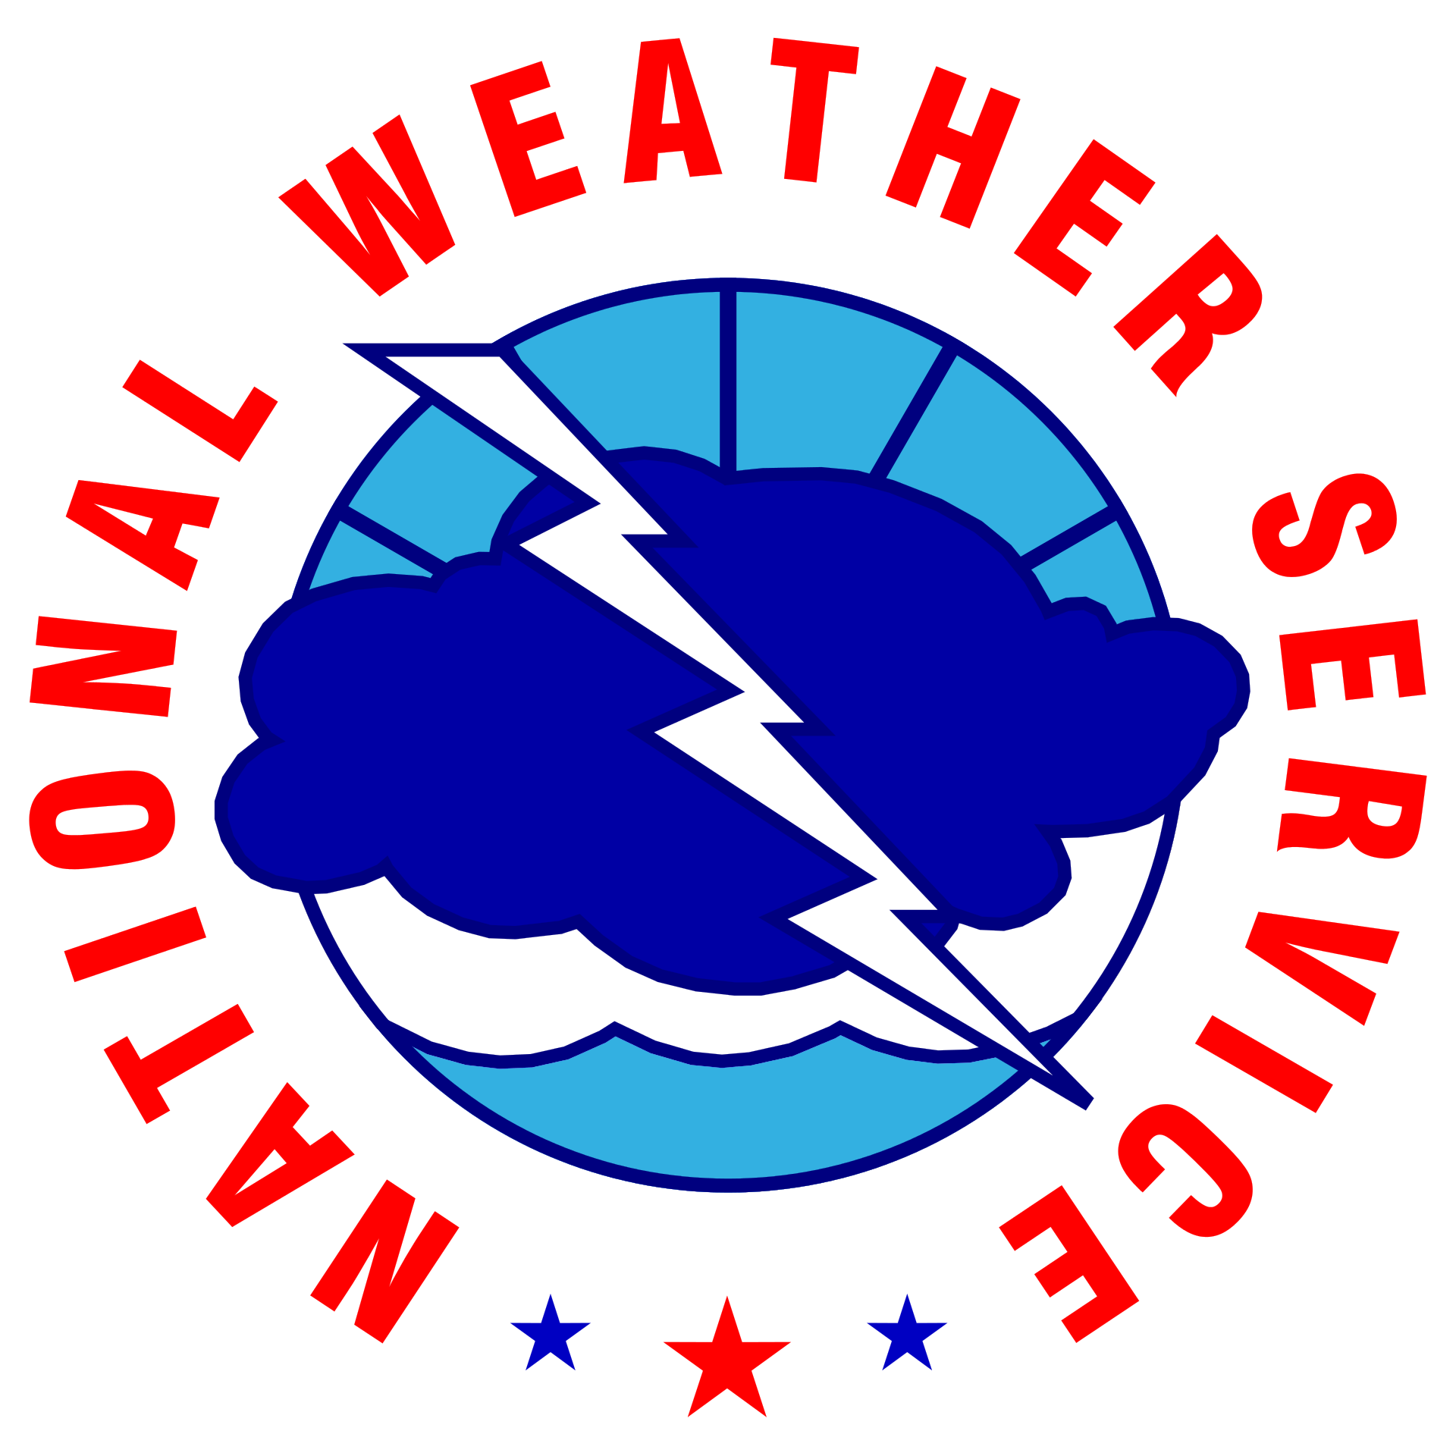
NOAA/NWS Lightning Toolkit

GOLF FACILITY
LIGHTNING SAFETY, ENTER ORG. NAME

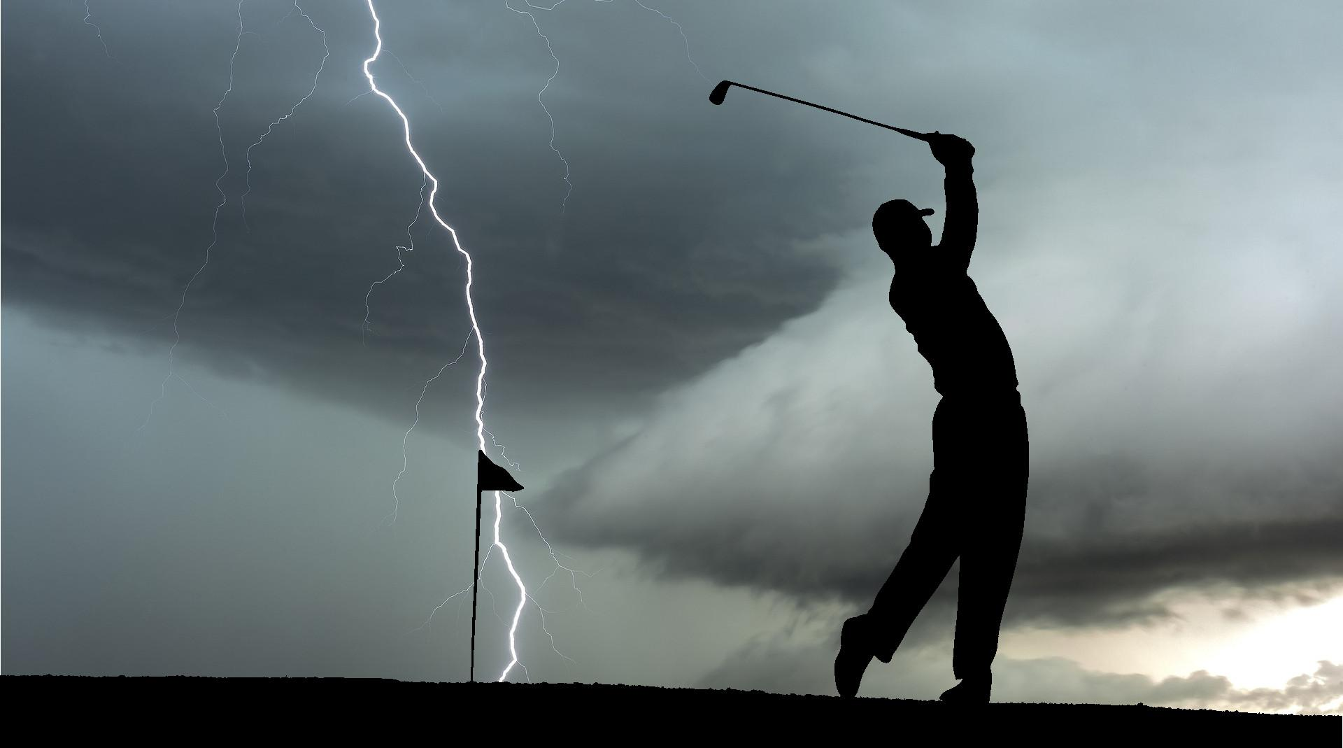

Why This Matters
The National Weather Service (NWS) has implemented a voluntary recognition program to help golf facilities better protect staff and patrons from the dangers of lightning. Eligible sites include any outdoor golf venue such as a country club, golf course, driving range, or golf entertainment facility.
This program is designed to help reduce the risk of lightning related threats through improved preparedness on the part of the facility staff and increased public awareness of the hazards associated with thunderstorms and lightning. Those who complete the process will be recognized for their proactive efforts in lightning safety.
The National Weather Service is committed to raising lightning safety awareness.

Protect Your Staff & Patrons From Lightning Dangers
The NWS recognizes the efforts of golf facilities that follow these guidelines to protect staff and patrons from the dangers of lightning. These guidelines may be satisfied by incorporating data/services provided by America's weather industry:
- Information Reception: The venue must have access to lightning proximity data and continuous access to information about NWS warnings. Most preferable methods for lightning data are:
  - A locally-run lightning detection system with a display unit on site.
  - Subscription to a commercial notification system.
However, websites/apps with lightning data may be satisfactory when combined with a dedicated weather watcher.
- Decision Support Standards: The facility must have a written lightning safety plan for both day-to-day operations as well as special events¹. The plan includes written instructions on how to contact local emergency management (EM for special events, and local police and fire personnel for day-to-day operations) and a weather service provider (e.g., provider from America’s Weather Industry or NWS).
- Public Notification Plan: The facility must have several means to notify its patrons that a lightning threat exists. Options include Outdoor Warning Siren(s), streaming television/radio broadcast, text/email message alerts, use of social media, and staff announcements.
- Protection Program: The facility must have means to shelter patrons. This would include providing substantial lightning-safe structures or vehicles (ex. clubhouse, restrooms, and maintenance buildings) ideally no more than ½ mi away from any point on the facility grounds, and signs indicating where shelters are located. The venue should investigate lightning protection equipment that intercepts lightning and diverts the discharge away from patrons and staff. NOTE: Golf carts are NOT lightning-safe vehicles
- Education: The NWS can provide lightning safety education materials. The facility should ensure it informs patrons of lightning precautions it has taken and the actions patrons should take when notified of a lightning threat.
¹Special Event: Event (amateur/professional tournament, etc.) where a significantly larger number of guests (spectators, local media, etc.) and staff will be at the facility than a normal day.
Lightning Safety Plan for (enter org. name)

Before the Event
Name of Weather Watcher will ensure a weather situational awareness plan² is in place anytime the facility is open. Staff will monitor the local weather via three or more of the following services: television news coverage, the Internet, mobile devices, cable and satellite weather programming, commercial services, NOAA weather radio, and National Weather Service (NWS) forecasts.
NWS Advisories, Watches, Warnings and Hazardous Weather Outlooks (HWO) can be monitored at http://www.weather.gov/Click to finish office link. (Links to all NWS offices) Thunderstorms and severe weather forecasts also are online at http://www.spc.noaa.gov .
If thunderstorms are forecast, staff will review the safety plan at the beginning of the day and identify the responsible officials and chain of command to implement the safety plan. Specifically, at least one staff member will be designated as a weather watcher who will notify the rest of the staff of the status of any thunderstorm that may threaten the safety of patrons.

Public Information
If thunderstorms are in the forecast, a staff member (pro shop staff, starter, etc.) will notify golfers prior to them beginning their round. Lightning safety guidelines and shelter locations will be printed on the scorecard and displayed in the golf cart³.
²Situational Awareness Example: Site has a computer with internet access designated for monitoring local weather web sites. A television is tuned to a channel dedicated to weather. A lightning detection system display unit is tested to ensure it is operable prior to the event. All weather reception and communication methods are tested to ensure functionality.
³Not required if the information is printed on the scorecard and every cart is equipped with a card.
For more information on NWS support for special events, visit: https://www.weather.gov/media/stormready/resources/specialevents.pdf

Before the Event (Cont.)

Designated Lightning-Safe Structure(s) or Vehicles
- Click or tap here to enter text.
- Click or tap here to enter text.
- Click or tap here to enter text.
- Click or tap here to enter text.
- Click or tap here to enter text.
If a substantial building is not available, enclosed motor vehicles can provide shelter as long as patrons do not touch the metal framework during the thunderstorm (golf carts are not safe vehicles).
No place outside is safe if lightning is in the vicinity. Partially enclosed shelters are not safe. If no safe shelter is available, direct patrons to stay away from the tallest objects trees, light poles, flag poles), metal objects (fences or golf clubs), standing pools of water, and fields.

During the Event
The weather watcher will use weather monitoring and lightning detection tools along with local observations⁴ to help determine the proximity of lightning and which safety actions to implement. The direction and speed of an approaching thunderstorm should be accounted for along with locally developing storms that may form nearby or overhead. If lightning is in the vicinity, the following procedures are recommended:
Please note: lightning radii will vary based on the maximum distance from shelter for each golf facility. Use the lightning radii chart provided to determine the thresholds for your facility.

Monitor Stage: When lightning is detected within 15 (click to edit) miles of the venue:
- Weather watcher notifies staff of elevated lightning monitoring.
- Facility staff notifies anyone near or in the clubhouse of the threat.
- Additional patrons should be held at the clubhouse and not allowed access to the facility.

Caution Stage: When lightning is detected within 12 (click to edit) miles of the venue:
- Weather watcher notifies staff of elevated lightning monitoring.
- Weather watcher determines storm speed/direction using a radar estimate or text from NWS warnings/statements.
- Facility staff notifies anyone near or in the clubhouse of the threat.
- If more organized thunderstorms (supercells, squall lines, and bow echoes) are headed for the venue, an evacuation will be necessary. (see PA system evacuation announcements)
- If sufficient time allows, and it is safe to do so, staff members may need to go out onto the facility to ensure everyone is heading to shelter

Continued, next page

⁴Without technology available, the best method for local observations to determine if lightning is within an unsafe range is to listen for thunder, watch for lightning, and remember that “When Thunder Roars, Go Indoors!”

During the Event (Cont.)

Action Stage: When lightning is detected within 8 (click to edit) miles of the venue:
- Weather watcher notifies staff of nearby lightning threat and the facility warning signal is manually or, preferably, automatically activated.
- Facility staff informs anyone in or near the clubhouse that play has been suspended due to lightning in the area.
- All patrons are directed to the nearest lightning-safe structure or vehicle (see designated shelters).
Watches & Warnings

If a Severe Thunderstorm or Tornado Watch is in effect:
A watch indicates that conditions are favorable for severe weather to develop. The weather watcher will communicate this information to the facility staff, indicating that elevated thunderstorm monitoring is occurring. Vital information to be shared will include the threats with the watch and the time that it is in effect until.

If a Severe Thunderstorm or Tornado Warning is in effect:
A warning means that severe weather has been detected and may be imminent in the locale. The weather watcher will communicate this information to the facility staff, indicating that the thunderstorm may be imminent. Vital information to be shared will include the threats with the storms and the time that the warning is in effect until. If the threat is imminent, an evacuation of the facility will take place.

If the weather watcher has questions about a storm, they can contact a commercial weather service provider at Click to add phone number. The NWS is especially concerned that you are prepared for hazardous weather, and will want to talk with your service provider from America’s Weather Industry well before the event. Your service provider can contact the local NWS office at Click to add phone number.

During the Event (Cont.)
Public Address System Evacuation Announcements
In a case where thunderstorms are in the forecast and an evacuation is possible that day, it should be communicated, either through signs or conversation that:
“Inclement weather, including lightning, is forecast today and may lead to the suspension of play. Those of you who wish to leave the course for safety will be permitted to re-enter ___________________________________ with your receipt, or a rain-check may be issued if you choose not to return after the inclement weather has passed.”
In the case of an evacuation, facility staff should communicate some version of the following:
“Inclement weather, including lightning, is in the vicinity of ___________________________________. Play has been suspended until the weather no longer poses a danger to this area. Please make your way to the nearest lightning-safe structure or vehicle. Once the storm clears, we will notify patrons of the resumption of play. At that point, you may either continue play, or request a rain-check to play at a further date.”
Resuming Play
- If the venue is consulting with a professional meteorologist that is using real-time lightning data, play may resume only if all of the following conditions are met:
  - Lightning has moved beyond 8 miles of the venue.
  - The storm motion is taking the lightning activity away from the venue.
  - The threat of new lightning strikes within 8 miles of the venue has ended.
- If the venue is not consulting with a professional meteorologist that is using real-time lightning data, the venue will wait 30 minutes after no observed thunder or lightning during the day or thunder at night before resuming activities.
Golfers will then be notified via (insert communication methods) that the lightning threat has ended and play can resume. However, please be advised that another evacuation or suspension of play may be required as conditions dictate.

After the Event
The weather watcher will remain on duty until the facility closes. A review of the weather’s impact on course operations and the effectiveness of the safety plan will occur between the weather watcher and facility management.

Venue Contacts
The venue management should have written instructions on how to contact local emergency management and the National Weather Service for information relative to the safety of their patrons.
National Weather Service Contact | Click or tap here to enter text.
Emergency Management Contact | Click or tap here to enter text.
Police Contact | Click or tap here to enter text.
Fire Contact | Click or tap here to enter text.
Other Contact | Click or tap here to enter text.

Venue Preparation Checklists

Information Reception
The facility should investigate the installation of a lightning detection system with a display unit or subscribe to a commercial lightning detection & notification system. In addition, the facility should have a NOAA weather radio on location.
☐ Lightning Detection System: Click or tap here to enter service name.
☐ Commercial Lightning Detection Network: Click or tap here to enter provider.
☐ Mobile device
☐ Internet (subscription for alerts): Click or tap here to enter provider.
☐ NOAA Weather Radio (NWR)
☐ Television (Local network or Cable TV)
☐ Radio Station (AM/FM) - EAS Reception
☐ Amateur Radio
☐ Other: Click or tap here to enter text.

Decision Support Standards
☐ Completed Toolkit for Safety Plans
☐ Staff Informed on Plans
☐ Designated Weather Watcher
☐ Lightning Proximity Actions
☐ Other: Click or tap here to enter text.

Venue Preparation Checklists (Cont.)

Public Notification Plan
The facility should have several means to notify its patrons if a lightning threat exists. This could include a public alert system, streaming television/radio broadcast, text/email message alerts, use of social media, and staff announcements.
☐ Outdoor Warning Siren(s)⁵
☐ Golf Cart GPS Display Notification
☐ Video Board Message Developed for Events
☐ Public Address Announcement
☐ Social Media
☐ Other: Click or tap here to enter text.

Protection Program
The venue should have means to shelter and protect its patrons. This would include a written emergency operations safety plan for evacuation of a stadium, signs indicating where lightning-safe structures or vehicles are located. Also, the venue should investigate lightning protection equipment that intercepts lightning and diverts the discharge away from patrons and staff.
☐ Lightning Rods Installed
☐ Primary Shelters Designated and Marked
☐ Shelter Location Signs Posted
☐ Other: Click or tap here to enter text.
⁵Signals should follow the recommendations from the USGA rules of golf “Suspension of Play Due to A Dangerous Situation” (Appendix I Part C-5).
The following signals are generally used and it is recommended that all Committees do similarly:
-Discontinue Play Immediately: One prolonged note of siren.
-Discontinue Play: Three consecutive notes of siren, repeated.
-Resume Play: Two short notes of siren, repeated.

Venue Preparation Checklists (Cont.)

Education
Lightning safety materials from the National Weather Service are available for interested venues. Venues should ensure that guests are made aware of lightning safety precautions that the venue has taken and the actions which patrons should make when notified of a lightning threat
☐ Venue Staff Safety Training
☐ Event Lightning Safety Day
☐ Lightning safety Guidelines on Scorecard
☐ Lightning Safety Guidelines on Golf Cart
☐ Plans coordinated with Fire, EMS, and Police
☐ Other: Click or tap here to enter text.

Lightning Radii Chart
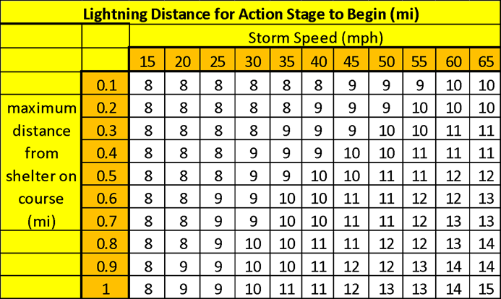
This chart is created using the assumption that golf carts have an average speed of 12 mph, it will take people 3 minutes to receive the alert, pick up their ball, and find the location of the nearest shelter, and that everyone should be in a lightning-safe structure or vehicle before there is lightning reported within 8 miles of the golf course.

How to Use This Chart–

Before the Event:
- Use a map to find the furthest distance from shelter at any point on your golf course. (This will remain constant for all weather events.)
The maximum distance from shelter at any point at this facility is (click to edit) miles.
- Find the corresponding row on the left side of the chart to the nearest tenth of a mile. Ex. Max distance is 0.5 miles. Corresponding line on chart is: 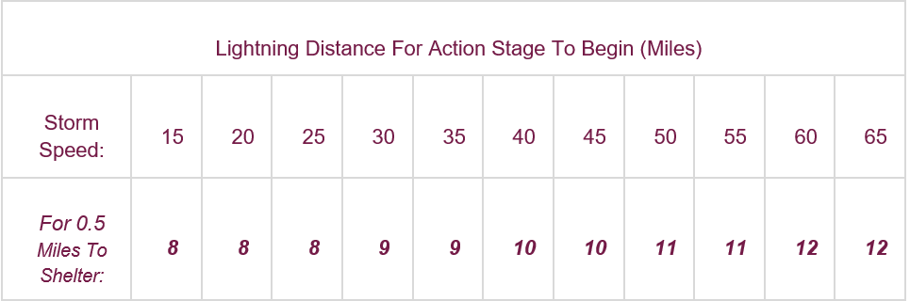

Lightning Radii Chart (Cont.)

How to Use This Chart (Cont.)

During the Event:
- Determine the storm speed through radar estimation or through the NWS or local media. Storm speed is (click to edit) mph.
- Find the corresponding column on the chart to determine at what lightning distance the action stage needs to be implemented. Ex. Storm speed of 45 mph.
Lightning Distance For Action Stage To Begin (Miles)
Storm Speed: | 15 | 20 | 25 | 30 | 35 | 40 | 45 | 50 | 55 | 60 | 65
For 0.5  Miles To Shelter: | 8 | 8 | 8 | 9 | 9 | 10 | 10 | 11 | 11 | 12 | 12

- Begin taking action at the corresponding mileage you discovered on the chart.
(10 mi in this example).

Lightning Safety Sheet
Local NOAA Weather Radio Transmitter Frequency: 162.XYZ MHz (Click or tap here to enter).
Local National Weather Service Office Phone Number: Click to add phone number
Local National Weather Service Office Webpage: https://weather.gov/Click to finish office link.
Local Emergency Manager Phone Number: Click to add phone number
Local Police Phone Number: Click to add phone number
Local Fire Phone Number: Click to add phone number
Professional Weather Services Phone Number (if applicable): Click to add phone number

Fill this chart out specifically for your venue
Lightning Distance for Action Stage to Begin (Miles)
Storm Speed: | 15 | 20 | 25 | 30 | 35 | 40 | 45 | 50 | 55 | 60 | 65
Max: X.Y  Miles To Shelter: | X.Y miles | X.Y miles | X.Y miles | X.Y miles | X.Y miles | X.Y miles | X.Y miles | X.Y miles | X.Y miles | X.Y miles | X.Y miles

