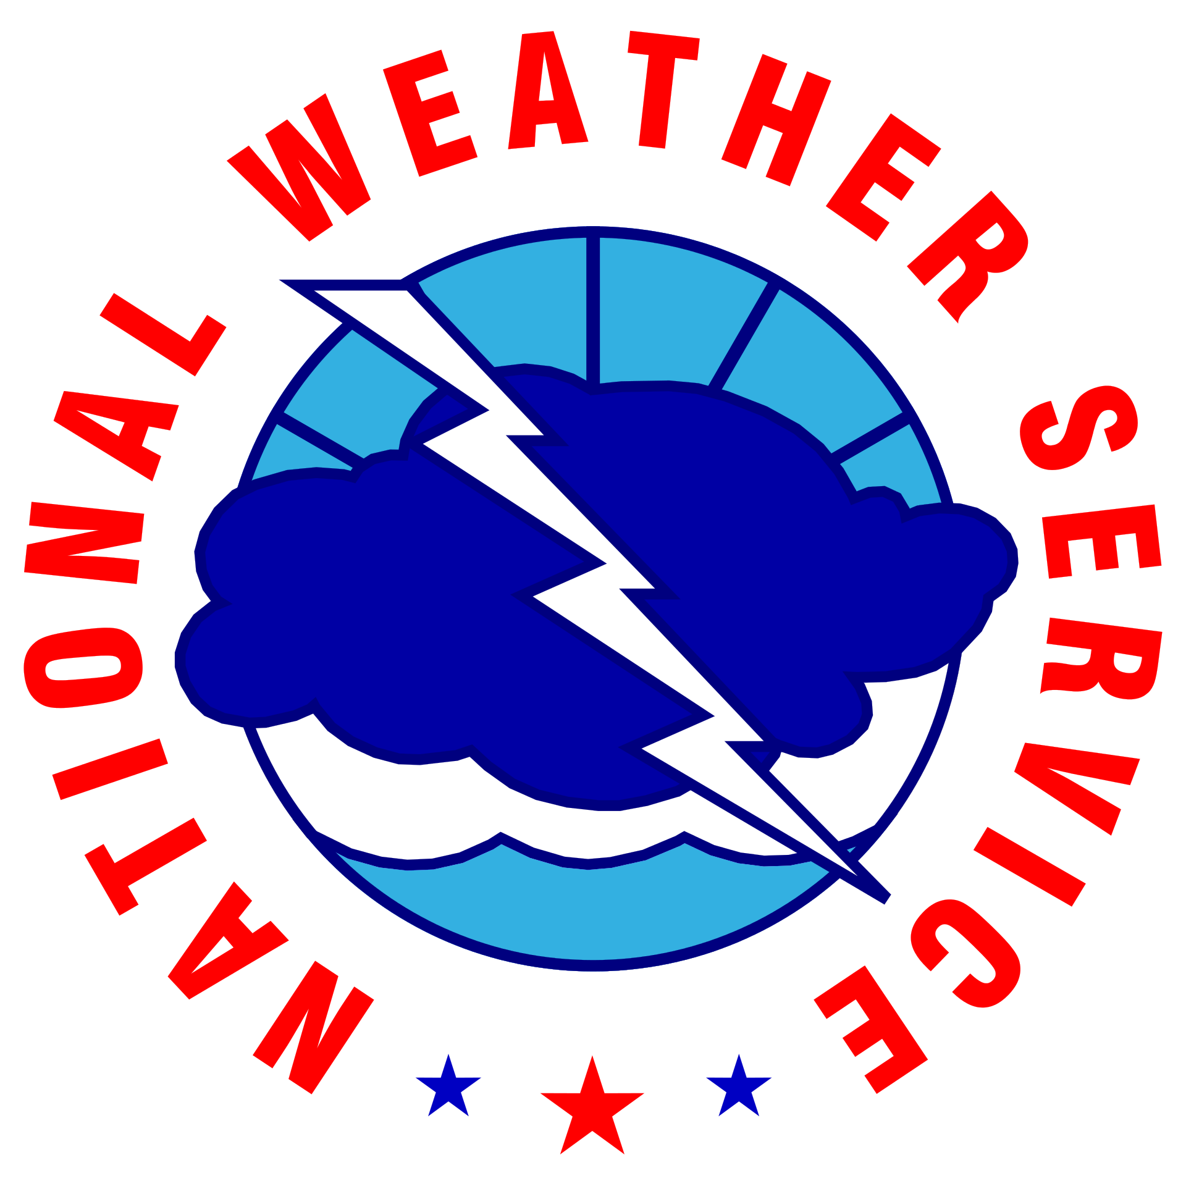
NOAA/NWS Lightning Toolkit

LIFEGUARD & BEACH PATROL
LIGHTNING SAFETY, ENTER ORG. NAME

Why This Matters
Every year, lightning strikes and kills people on or near bodies of water. Summer is the peak season for outdoor and water-related activities, and when most lightning deaths and injuries occur. As recently as 2021, a lifeguard was fatally struck by lightning in New Jersey . Lightning cannot be prevented, but the vulnerability of lifeguards, beach-goers, and patrons near bodies of water can be minimized. Vulnerable locations include: beaches, indoor and outdoor pools, diving boards, lifeguard stands, and nearby outdoor recreational facilities. While every state has reported lightning-related fatalities, the highest numbers are reported in states bordering the Great Lakes, southern states bordering the Atlantic Ocean and Gulf of Mexico, and the four corners states of Colorado, New Mexico, Utah, and Arizona. This document serves as a guideline for developing a lightning safety plan and communicating lightning safety information. These guidelines are aimed primarily at areas of the country with moderate to high lightning hazard levels, but may be applied anywhere.
The National Weather Service is committed to raising lightning safety awareness.

Protect Your Staff & Patrons from Lightning Dangers
The NWS recognizes the efforts of Lifeguard agencies and Beach Patrols that follow these guidelines to protect staff and patrons from the dangers of lightning. These guidelines are meant to be customized to satisfy an agencies’ or patrols' unique needs, but should still include the following principles.
- Develop an Emergency Action Plan: This plan should be customized to fit the unique needs of the organization who is appointing. The customizations should not keep the key principles in the plan, unless there is documented justification for a specific principle to be excluded. The emergency action plan (EAP) should also include instructions on who is responsible for monitoring the weather conditions, the distances and conditions of the three threat levels, and the persons responsible for managing and disseminating important information about an event.
- Educate: Annual training for lifeguard and beach patrol units should include lightning awareness and a review of protocols in their hazardous weather safety plan. The training should also include information on what shelters are safe from lightning and where those shelters are.
- Forecasting Tools: Are the tools available to the weather watcher for monitoring weather conditions. These tools could include commercial services, television networks, internet websites, radio forecast (AM/FM, Amateur, NWS), Local NWS Office, or Emergency Management Office.
- Warning and Communications Tool: Are the tools used to disseminate information about weather conditions, and life threatening lightning events. These tools should include options for sharing important information during normal conditions such as lightning safety PSA signage, information boards, and flag systems. Tools should also be included when disseminating information is more time sensitive, such as Two-way Radios, Public Address systems, social media posts, and email/SMS alert messages.
- Daily Operations: This should include the details on how the weather watcher is designated, what conditions they should be monitoring for, and who needs to be contacted, if anyone, when conditions meet threat levels and action needs to be taken to address them.
NOTE: This plan contains options that should be tailored to local circumstances, available equipment, and predetermined evacuation options. For locations with high attendance or lack of nearby shelter, it may be prudent to initiate actions earlier than suggested.
[1] National Fire Protection Association (NFPA) 780- Standard for the Installation of Lightning Protection Systems

Lightning Safety Plan for (enter org. name)

Before the Event

Annually
Enter name of organization will ensure an emergency action plan (EAP), is in place and reviewed Enter frequency (annually, seasonally), if not more frequently to ensure the plan’s points of contact and details are accurate and adjusted for any changes since the last review. Enter name of official will also make sure all employees are aware of their roles and responsibilities in the EAP, and a schedule has been established for appointing a daily weather watcher.
Enter name of organization should plan regular lightning safety, and lightning injury response training for all employees. Optionally, this could be in conjunction with NWS Enter city/town of NWS Forecast Office.

Daily Operations
The weather watcher will monitor the local weather via three or more of the following services: television news coverage, the Internet, mobile devices, cable and satellite weather programming, commercial services, NOAA weather radio, and National Weather Service (NWS) forecasts.
NWS Advisories, Watches, Warnings and Hazardous Weather Outlooks (HWO) can be monitored at http://www.weather.gov/Click to finish office link. (Links to all NWS offices) Thunderstorms and severe weather forecasts also are online at http://www.spc.noaa.gov/ If the weather watcher has questions about a storm, contact the National Weather Service in Enter name of NWS Forecast Office at Click to add phone number.
If thunderstorms are forecast for the day, officials will identify the responsible officials and chain of command to implement the emergency action plan. The designated weather watcher for the day will notify officials of the status of any thunderstorm that may threaten the safety of the lifeguards and the patrons.
For more information on NWS support for special events, visit: https://www.weather.gov/media/stormready/resources/specialevents.pdf

Before the Event (Cont.)

Public Information
Where possible, lightning safety guidelines and PSA signage will display in high volume public areas, with information about evacuation procedures, and designated lightning safety shelters, if applicable. If thunderstorms are in the forecast, officials will notify staff and patrons via the Enter name of announcement system with as much advanced lead time as possible.

Designated Lightning-Safe Structure(s) or Vehicles
- Click or tap here to enter text.
- Click or tap here to enter text.
- Click or tap here to enter text.
- Click or tap here to enter text.
- Click or tap here to enter text.
If a substantial building is not available, enclosed motor vehicles can provide shelter as long as patrons do not touch the metal framework during the thunderstorm.
No place outside is safe if lightning is in the vicinity. Partially enclosed vending areas and picnic shelters are not safe. If no safe structure is available, direct patrons to stay away from the tallest objects (lifeguard stands, trees, light poles, flag poles), metal objects (fences or bleachers), standing pools of water, and open fields. If patrons are still in transit to the waterfront, encourage them to remain in their vehicles until the lightning threat has ended.

Before the Event (Cont.)

Unsafe Locations - Do Not Use For Shelter
- Beaches
- Water
- Open-sided pavilions (such as picnic areas)
- Restrooms, changing facilities, and showers
- Lifeguard stands that are not fully enclosed and compliant with NFPA 7801 lightning guidelines.
- Tents
- Boats that are not designed or retrofitted to be compliant with NFPA 7801 lightning guidelines
- Small personal water crafts (jet skies)
- All-Terrain Vehicles (ATVs)

During the Event
The weather watcher will use weather monitoring and lightning detection tools along with local observations² to help determine the proximity of lightning and which safety actions to implement. The direction and speed of an approaching thunderstorm should be accounted for along with locally developing storms that may form nearby or overhead. If lightning (cloud-to-cloud or cloud-to-ground) is in the vicinity, the following procedures are recommended.

When lightning is detected within 20 (click to edit) miles: [Threat Level 1]
- Weather watcher notifies management and staff of threats via Click or tap here to enter method.
- If it appears the thunderstorm is moving toward the site, or if a more organized thunderstorm or cluster of thunderstorms (supercells, squall lines, bow echoes) are headed for the site, a 30-minute lead time or more should be considered for protective actions. The weather watcher should attempt to estimate the speed and direction of the storm movement to determine when it will enter a 10 (click to edit) mile radius of the location.
- Protective actions
  - Consider closing facilities that do not provide protection from lightning
  - Notify the public of the lightning threat and recommended actions:
    - Return to shore
    - Prepare to leave and find shelter.
  - Weather watcher contact enter name at phone number to consider initiating predetermined evacuation plans
  - Ensure staff takes action to protect themselves
Continued, next page

²Without technology available, the best method for local observations to determine if lightning is within an unsafe range is to listen for thunder, watch for lightning, and remember that “When Thunder Roars, Go Indoors!”

During the Event (Cont.)

When lightning is detected within 15 (click to edit) miles: [Threat Level 2]
- Weather watcher notifies management and staff of new threat level via Click or tap here to enter method.
- Protective actions
  - Consider closing facilities that do not provide protection from lightning
  - Notify the public of threat and recommended actions:
    - Exit the water
    - Finish preparing to leave and encourage patrons to voluntarily find shelter (identify appropriate shelter).
  - Start Initiating predetermined evacuation plans and prepare predetermined shelters if needed.
  - Weather watcher contact enter name at phone number to consider initiating predetermined evacuation plans
  - Ensure staff takes action to protect themselves

When lightning is detected within 10 (click to edit) miles: [Threat Level 3]
- Weather watcher notifies management and staff of new threat level via Click or tap here to enter method.
- Protective actions
  - Close facilities that do not provide protection from lightning
  - Notify the public of imminent threat and to take recommended action:
    - Exit the water, outdoor areas, and all unprotected shelters
    - Leave and find shelter.
  - Implement predetermined evacuation plans
  - If not already done, enter name at phone number initiates predetermined evacuation plans
- Ensure staff takes action to protect themselves

Continued, next page

During the Event (Cont.)

Responding to Lightning Injuries:
- Ensure scene safety (victims do not carry an electrical charge and can be touched)
- Follow local protocols for trauma injury and triage. If necessary, safe, and appropriate, move the victim to a safe place away from the threat of another lightning strike
- Summon an ambulance as needed according to local protocols
- CPR and/or AED may be necessary
- Heart irregularities, shock, or sudden loss of consciousness are possible. Keep the conscious victim calm and monitor closely

After the Event

All Clear
The weather watcher will continue to monitor the proximity of thunderstorms and utilize local observations to make an informed decision, determining the appropriate time to recommend reopening outdoor facilities. Management may then allow for normal activities to resume after 30 minutes of no detected lightning strikes within a 10 (click here to edit) mile radius of the site. Notify the public that outdoor activities can resume.
If desired, enter organization name could review the actions taken during a lightning event to ensure the current EAP is best addressing the lightning threats in their part of the venue and the population they are protecting. The information can also be used to better train employees, and partnering agencies who are responding to these lightning events.

Location Information
The location information should best represent the area in which the weather watcher is responsible for monitoring the weather conditions. If the coverage area is greater than threat level 1’s Radius (20 (click here to edit) miles) additional locations should be added to best ensure accurate coverage for the area.
Lifeguard Agency’s Latitude and Longitude | Click or tap here to enter text.
Additional Coverage Area’s Latitude and Longitude | Click or tap here to enter text.

Contacts
The weather watcher should have written instructions on how to contact local emergency management and the National Weather Service for information relative to the safety of their patrons.
National Weather Service Contact | Click or tap here to enter text.
Emergency Management Contact | Click or tap here to enter text.
Chain of Command Staff Contact | Click or tap here to enter text.
Other Contact | Click or tap here to enter text.
Commercial Lightning Detection Service | Click or tap here to enter text.
Commercial Forecasting Service | Click or tap here to enter text.

Preparation Checklists

Safety Plan
Have plans for when lightning becomes a threat to the site. Set up lightning proximity criteria and resultant safety tools and actions.
☐ Emergency Action Plan (EAP) Developed
☐ Staff Training & Education Plan
☐ Staff Training for Basic Lightning Safety
☐ Staff Training responding to Lightning Strike Injuries
☐ Staff Training on Where Lightning Shelters are Located
☐ Staff Participate in SKYWARN training or Weather Safety talks
☐ Daily Operations Plans
☐ Forecasting Tools
☐ Warning & Communication Tools

Weather Monitoring Tools
These are tools used to gather forecasts and for monitoring current weather conditions.
☐ NOAA Weather Radio (NWR)
☐ Mobile devices/apps
☐ Internet Resources
☐ Commercial Service Click or tap here to enter provider.
☐ Television (local network or cable TV)
☐ Amateur Radio
☐ Local Emergency Management Office
☐ Local National Weather Service Office Click or tap here to enter info.
☐ Other: Click or tap here to enter text.
Continued, next page

Preparation Checklists (Cont.)

Lightning Detection Tools
These are tools used specifically for monitoring and tracking the threat of lightning as events approach, impact and depart the area.
☐ Local Lightning Detection System, or Device(s)
☐ Commercial Lightning Detection Network
☐ Flash to Bang Rule
☐ Other: Click or tap here to enter text.

Warning and Communication Tools
Have several means to notify patrons if a lightning strike exists..
☐ Two-way radio
☐ Public Address Address System
☐ Telephones, including mobile phones
☐ Official Agency Social Media Accounts
☐ Air Horn or Megaphone Announcements
☐ Whistle systems
☐ Sign Boards
☐ Hand Flag Communication
☐ Flag Systems
☐ Radio broadcasts
☐ Television broadcasts
☐ SMS (Text Message) Alerts
☐ Email Alert Messages
☐ Lightning Safety PSA Signage
☐ Vehicle Announcement Patrol
☐ Other: Click or tap here to enter text.
Continued, next page
Preparation Checklists (Cont.)

Safety Shelters
Identify areas of safe shelter. This could include signs indicating where shelters are located and substantial structures on the site’s property (e.g. enclosed buildings that are grounded with wiring and plumbing that are easily accessible). Consider investigating other lightning protection equipment which could act as another measure to divert strikes to the tallest object and away from people.
☐ Lightning Rods Installed in compliance with NFPA 780 Guidelines
☐ Primary Shelters Designated and Marked
☐ Secondary Shelters Designated and Marked
☐ Weather Evacuation Signs Posted

