 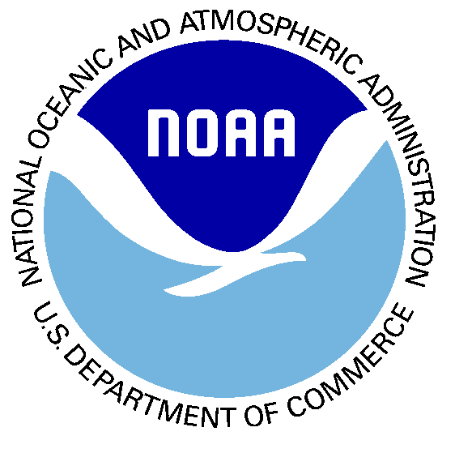 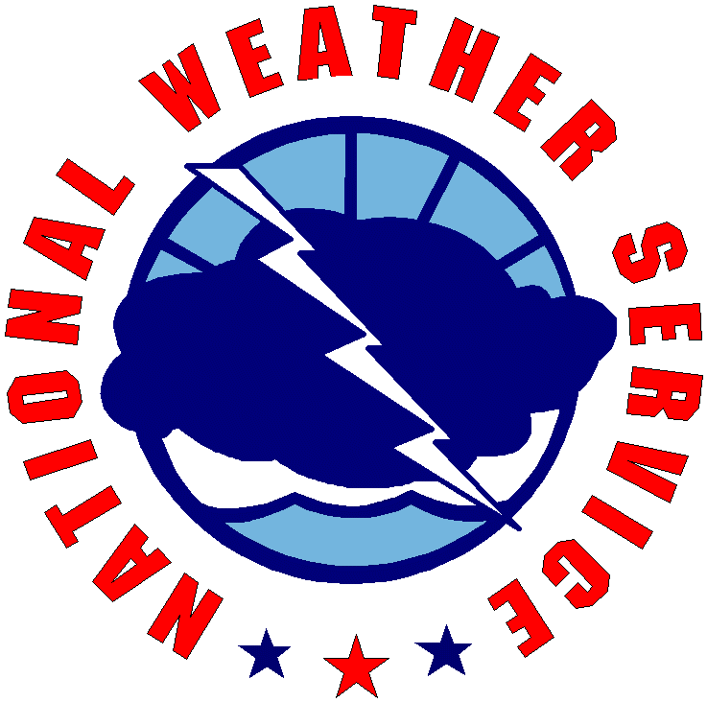

**United States Department of Commerce**

**National Oceanic and Atmospheric Administration**

**National Weather Service**

Certificate of Training

***Your Name Here***

is hereby recognized for successful completion of

***Severe Weather Storm Spotters Training Course***



***2024 Training***

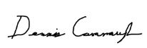

***______________________________***

***Dennis Cavanaugh***

***Warning Coordination Meteorologist***

***WFO Little Rock, Arkansas***