U. S. DEPARTMENT OF COMMERCE  National Oceanic and Atmospheric Administration  National Weather Service – Pacific Region |  |  | Certificate Number: | 60,454 | Date of Issue: | 30 Sep 2020
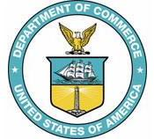 | Certificate of Authority  to take  Weather Observations
This is to certify that
Jack Bay
is qualified and authorized to take weather observations subject to the conditions stated in the Weather Service Policy Directives.
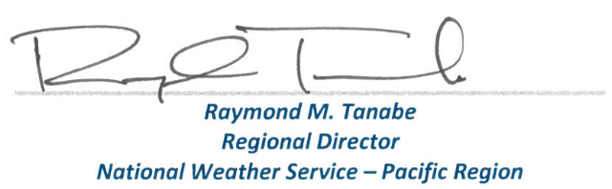
IMPORTANT:
1. A certificate shall remain valid provided:
a. The observer maintains proficiency.
b. The observer takes, encodes, and records on the official station log the type of observation for which
the certificate is valid and with the frequency stated in NWSI 10-1301.
c. The observer possesses the visual acuity required by NWSI 10-1301.
d. The field supervisor requests revalidation or recertification within 45 days of change of station.
2. Failure to comply with the above automatically causes the certificate to lapse. An individual cannot take an
official weather observation with a lapsed certificate.
3. A certificate is cancelled if lapsed for 90 consecutive days.

CERTIFICATES MUST BE READILY ACCESSIBLE FOR INSPECTION AT ALL TIMES
Date | Location | Type of Observation | Initials
30 Sep 2020 | All PR Offices | Aviation

