NOTE:

The term "interim" on the report is in reference to the period of performance of the contractor support contract. If there was a follow on task in the next contract year, there might have been an additional test period and accompanying report. There was not. The report itself is the final report prepared for that project. It is the "final" report.

SFSC DOCUMENT CONTROL SHEET
TITLE: Interim Report For The Winter Test of Production All-Weather Precipitation Accumulation Gauge (AWPAG)Winter 2008-2009 |  |  |  | DATE: 12/30/08
ORIGINATORS: Gregory Whitaker
Documents may pass through four stages: Stage 1) if originated by SAIC, a document will go through an internal (contractor) review before delivery to the Test Director for review; Stage 2) if originated by the Government, the document will be delivered by the Originator to the Test Director for review; Stage 3) the Test Director will release the document for a five-day “Team” review cycle; Stage 4) comments will be returned through the Test Director for adjudication with the Originator and incorporation of comments where appropriate; document will be forwarded through the Test Director to the appropriate NWS office.
STAGE 1:  SAIC Review | REVIEWER | DATE RECEIVED | COMMENTS  (Y/N) | DATE RETURNED
STAGE 1:  SAIC Review | John Vogel | 12/30/2008 | Y | 12/30/08
STAGE 1:  SAIC Review | Barbra Childs | 1/2/2009
STAGE 1:  SAIC Review | Jennifer Dover | 12/30/2008 | Y | 12/31/08
STAGE 1:  SAIC Review | Paul Oosterhout | 1/2/2009
STAGE 1:  SAIC Review | Aaron J. Poyer | 12/30/2008
STAGE 2:  Test Director Review | Jennifer Dover | 1/2/2009
STAGE 3: | John Vogel
STAGE 3: | Barbra Childs
STAGE 3: | Paul Oosterhout
STAGE 3: | Aaron J. Poyer
STAGE 3: | John Vogel
STAGE 4:
Government Review
Remarks:

FINAL NWS REVIEW & APPROVAL: |  |  |  | DATE




INTERIM REPORT
For
2008-2009 Winter Testing of the All Weather Precipitation Accumulation Gauge (AWPAG)

Version 2
December 2008

Prepared for
National Weather Service W/OST 1

By


These data are furnished for technical information only. The National Oceanic and Atmospheric Administration does not approve, recommend, or endorse any product; and the test and evaluation results should not be used in advertising, sales promotion, or to indicate in any manner, either implied or explicitly, endorsement of the product by the National Oceanic and Atmospheric Administration.

THIS PAGE INTENTIONALLY LEFT BLANK

TABLE OF CONTENTS
1.0 BACKGROUND 5
2.0 PURPOSE 6
3.0 PERFORMANCE REQUIREMENTS 7
4.0 TEST SITES AND CONFIGURATION 7
4.1 Test Locations and Data Collection 7
4.2 Sensor Description 7
4.2.1 Production AWPAG 7
4.2.2 Production AWPAG in DFIR 8
4.2.3 Production AWPAG with OTT ATDD-Style Alter Shield 8
4.2.4 Heated Tipping Bucket 8
4.2.5 NWS 8-inch Manual Gauge 8
4.3 Weather Observations 9
5.0 METHODOLOGY 9
5.1 Weather Assessment 10
5.1.1 Comparability 10
5.1.2 False Reporting 11
5.2 Engineering Assessment 11
6.0 RESULTS 12
6.1 Event Summary 12
6.2 Hourly Comparisons 13
6.3 False Tips 14
7.0 CASE STUDY 15
8.0 CONCLUSIONS 16
9.0 REFERENCES 17
APPENDIX A - FIRMWARE VERSION DESCRIPTION A
APPENDIX B – WEATHER SUMMARY, JOHNSTOWN EVENTS A
APPENDIX C JOHNSTOWN, PENNSYLVANIA TEST BED B

1.0 BACKGROUND

The heated tipping bucket (HTB) was the initial precipitation accumulation gauge used when the Automated Surface Observing System (ASOS) was deployed. The sensor measures liquid accumulation, but is not specifically designed to accurately measure liquid equivalent of freezing or frozen precipitation. The accurate measurement of liquid equivalent accumulation in all types of liquid, solid, and mixed precipitation is an important part of the climate record. The National Weather Service (NWS) ASOS Product Improvement (PI) team evaluated commercial off-the-shelf (COTS) sensors from October 2000 to March 2001. The government down-selected to one vendor and a contract for design and development of ten pre-production gauges was awarded on September 25, 2001, to C.C. Lynch and Associates (CCLA) of Pass Christian, Mississippi, in partnership with OTT Hydrometry of Kempten, Germany.

Subsequent to the required environmental qualification testing of six pre-production gauges, approval for limited production of twenty sensors was granted to the contractor by the NWS. Operational acceptance testing of these sensors was conducted during the winter of 2002-2003 at selected ASOS sites across the United States.

In late August 2003, firmware version 3.58 was installed to replace version 3.55 in Sterling and Johnstown. The major change to V3.58 firmware was the re-design of the internal algorithm that determines the threshold for precipitation intensity. The new algorithm calculates the precipitation intensity threshold on a minute by minute basis resulting in a more accurate threshold with lower accumulation losses. In addition, all production balance mechanisms are now characterized for temperature influence at high and low extremes to develop a temperature compensation factor that minimizes performance differences among gauges. AWPAG firmware 3.59 was installed in November 2005 to allow for a user alterable low temperature orifice heater cut-off, but was removed in February 2007 due to a heater cycle that allowed for an ice bridge to form. See Appendix A for more information on the firmware versions that have been implemented with the AWPAG.

Precipitation intrusion was addressed with a redesign of the orifice that increased the overlap of the bottom of the orifice and the top of the catch bucket. Orifice heating was increased slightly to account for the larger orifice mass. Production AWPAGs reflecting these changes replaced the pre-production AWPAGs in October 2003. Testing during the winter of 2003-2004 produced inconclusive results at Johnstown most likely as a result of test bed “shadowing” by the large Double Fence Intercomparison Reference (DFIR) windshield that produced deep snow drifts in the test bed. This issue was addressed when the large DFIR was relocated from the windward side of the test bed at Johnstown, Pennsylvania.

Winter of 2004-2005 testing demonstrated that the AWPAG met the NWS hourly requirements, but failed to meet the event requirements due to under-reporting in sustained wind driven mixed and/or frozen precipitation. Based on these results, an 8-foot diameter Alter-style wind shield surrounding a production AWPAG/Tretyakov was added. This configuration equaled or exceeded the catch of the NWS reference gauge. Upon completion of this testing, CCLA/OTT Hydrometry designed and fabricated prototype 8-foot diameter Alter-style wind shields that bolted directly to the existing Tretyakov wind shield mounts for the winter 2005-2006 test. A significant improvement in performance was shown with the AWPAG with added 8-foot Alter shield versus the standard Tretyakov shield.

A more rigid shield mounting structure that eased AWPAG maintenance and a new lamella design was established for the winter 2007-2008 test. This shield was developed and manufactured by OTT and was based on the ATDD design. The new ATDD shield lamellas were slightly longer and the spacing between lamellas was slightly greater. These improvements were made to prevent the hoop from jumping out of the slots on the support arms. Fasteners now secure the hoop in the slot. Also, the new shield contains support arms which are perpendicular to the hoop arc, eliminating the possibility of a flipped lamella resting on that support arm.

In addition to testing the new shield design, firmware version 3.61 was evaluated. The primary improvement in the firmware was an adjustment to the orifice heater controller. This alteration was made to prevent ice from accumulating between the outer shell’s orifice and the precipitation bucket. Ice bridging has been a common problem in the AWPAG at several different sites during the winter season. The new firmware allowed the orifice heater to turn on when the temperature drops below 32°F. A manual adjustment was made so that instead of turning off at 17°F, the heater did not shut off until the temperature reached 10°F. The new heater controller firmware also allowed the operator to set the low temperature cut-off to any value below 30°F, and it eliminates the automatic 1-minute heater shut-off which occurs once every hour. This new version was meant to overcome another large obstacle by preventing false tips without missing “true” precipitation. False tips have been a problem in the recent past, due to ice bridges, large temperature fluctuations, and the impacts of surrounding wildlife. Several additional measures were taken to avoid this problem including better versatility in drastic temperature fluctuations, deleting certain “intensity rest” values, and optimizing the Temperature Compensation (TC) level.

2.0 PURPOSE

The purpose of this test is to perform a winter assessment of the production AWPAGs based on compliance with the AWPAG performance requirements in NWS specification D113-SP001. The results of these tests are intended to validate the final production AWPAG configuration.

The goals of the winter 2008 - 2009 test at Johnstown are:

- Determine test gauge comparability to collocated reference sensors, in all types of precipitation, based on the NWS AWPAG accuracy requirements in Section 3.0

- Determine compliance with requirements for false reports of precipitation accumulation.

- Compare gauge performance between the production AWPAGs with Tretyakov shields, production AWPAGs with the OTT ATDD style Alter shields and production AWPAGs in the large DFIR, which are used for reference purposes only.

- Study effects on AWPAG accuracy with the addition of 8-foot diameter Alter shields in wind driven frozen precipitation.

- Evaluate firmware version 3.61, and study effects of improvements on precipitation catch.

3.0 PERFORMANCE REQUIREMENTS

The following three paragraphs are the hydrometeorological performance requirements for the NWS AWPAG from Specification No. D113-SP001, Section 3.3.1.4:

The AWPAG shall be linear over the entire measurement range, with an accuracy of ±4% or ± 0.02 inch, whichever is greater, when compared to a standard National Weather Service 8-inch non-recording precipitation gauge installed at the standard height with a National Weather Service Alter shield. Comparisons will be made on hourly accumulations and event accumulations.

When compared to the standard National Weather Service 8-inch non-recording gauge described above, the AWPAG shall not false report (report accumulation in the absence of precipitation) more than 0.09 inches for a single, continuous 30-day period. The goal is that there are no false reports.
It is recognized that smoothing or filtering algorithms may be required in order to reduce false precipitation reports. If such algorithms are required, the maximum acceptable delay in reporting of precipitation due to filtering shall be five (5) minutes.

The methodology for verification of these performance requirements is detailed in Section 5.0

4.0 TEST SITES AND CONFIGURATION

4.1 Test Locations and Data Collection

Testing took place at Johnstown, Pennsylvania; the permanent winter test site operated by the NWS Sterling Field Support Center. See Appendix C for a map of the Johnstown test bed layout.

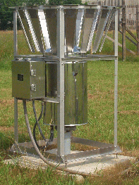
One minute data for the Johnstown test site was collected from all test sensors using a personal computer based data acquisition system (DAS). An ASOS heated tipping bucket was also included in the AWPAG data comparison. Data from all ASOS sensors at Johnstown is available for use in post-processing. Typical reference weather sensors include a freezing rain sensor, visibility, temperature/dew point sensor, wind speed and direction, precipitation identification, and ceilometer. Additionally, a heated sonic anemometer is installed at gauge orifice height in proximity to the precipitation gauges to assess wind-induced effects. These reference data were also used in post-processing, in verifying false precipitation reports from the test gauges, and in case study analyses.

4.2 Sensor Description

4.2.1 Production AWPAG

Two 56-inch capacity production AWPAGs were tested at Johnstown. Figure 1 depicts an installation of an AWPAG that is typical at an ASOS site, including mounting on a 3-inch pipe, 18 inches above grade, with a free-standing Tretyakov wind shield flush with the 59-inch orifice height.
Figure 1 Production AWPAG

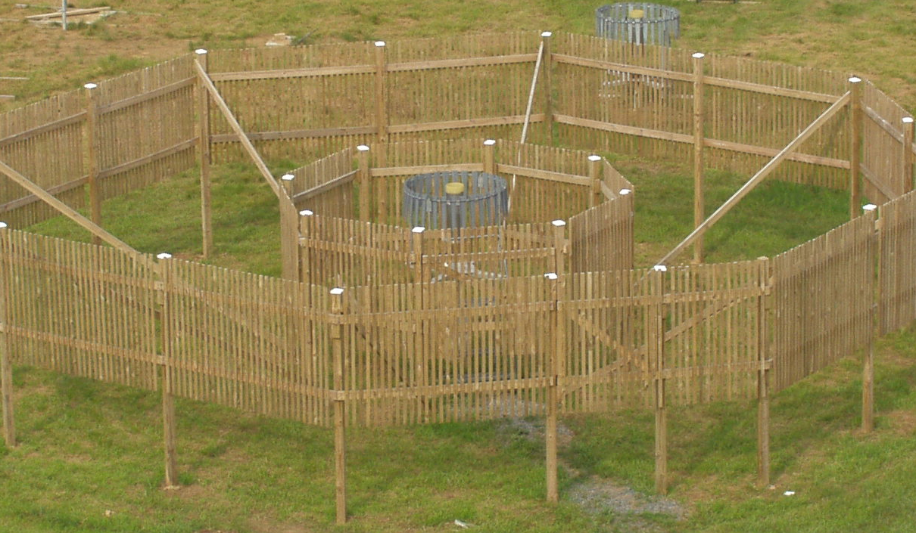
Production AWPAG in DFIR

One production AWPAG is installed at Johnstown in a large scale Double Fence Intercomparison Reference (DFIR) wind shield. The DFIR was built to minimize wind-influenced measurement losses (precipitation under-catch). This gauge was used only for comparison and not qualification.
Figure 2 AWPAG w/ Large DFIR

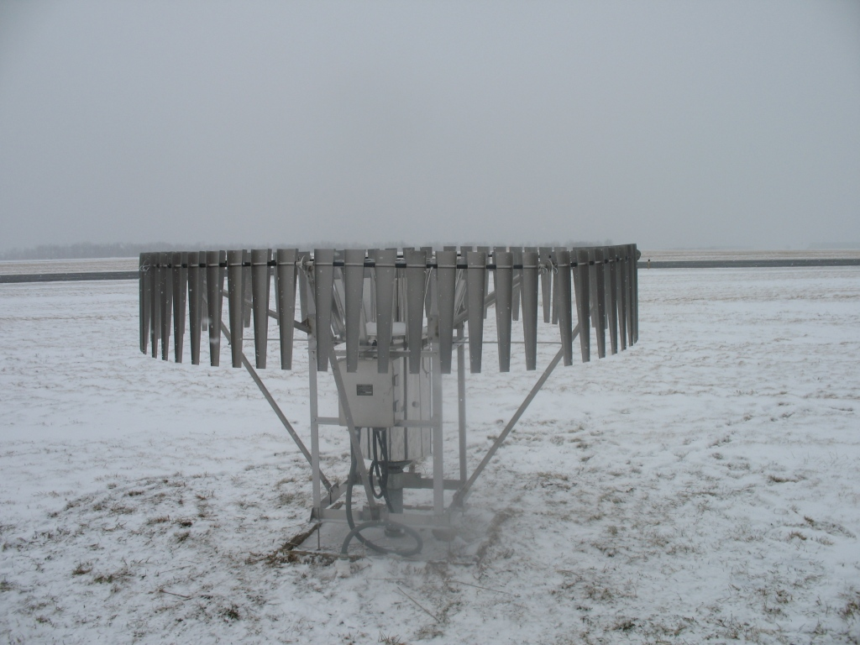

Production AWPAG with OTT ATDD-Style Alter Shield

Two production AWPAGs modified with an 8-foot diameter ATDD-style Alter shield were tested at Johnstown (Figure 3). These shields contained modifications that correct the two problems identified in testing of the previous OTT shield design. First, the hoops are prevented from jumping out of the slots on the support arms; second, the spacing of the lamellas was modified so that they no longer rest on the nearby support arms when flipped by the wind.
Figure 3 AWPAG with OTT ATDD style Alter Shield

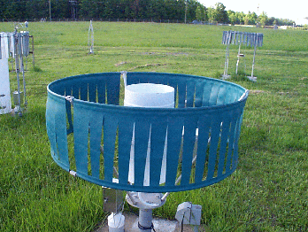

4.2.4 Heated Tipping Bucket

The standard ASOS HTB (Figure 4) was used as a comparison sensor for this test. The HTB gauges were not used to evaluate measurement accuracy of the test gauges, but did provide data for assessing improvements to ASOS precipitation measurements as a result of AWPAG deployment. HTB data were also used as an aid to determine false reports. The HTB gauges are installed with the standard ASOS vinyl wind shields one inch above the orifice height.
Figure 4 ASOS Heated Tipping Bucket

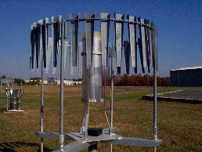
4.2.5 NWS 8-inch Manual Gauge

Four standard NWS 8-inch non-recording gauges were used for reference measurements of all types of precipitation at each test site (Figure 5). At the test site, two of the gauges were designated as hourly references and two as event references. All manual gauges at the test sites are installed with the orifice height at 60” (5 feet). Alter style wind shields were installed one inch above the orifice height on all of the manual gauges.
Figure 5 NWS 8-inch Manual Gauge

4.3 Weather Observations

Detailed surface observations were made by SAIC and NOAA/NWS staff at the test site during covered events. Observers were deployed to cover events when a significant period of wintry precipitation was forecasted to occur. For this test, event coverage decisions were made based on forecasts of snowfall of 2 inches or more, or on forecasts of freezing rain and/or ice pellets exceeding 2 hours. Once an event started, coverage continued until the precipitation ended and did not start again within approximately 15 minutes, or the hourly liquid equivalent accumulations decreased to less than 0.01 inch per hour for two hours.

The intent was two-fold at the observer’s discretion: 1) to avoid stopping an event prematurely when more significant precipitation is imminent, or 2) to needlessly prolong a significant event that has gradually tapered off to very light precipitation with no additional significant precipitation expected. For this test, valid events were those with reference amounts of 0.04 inches or more. Events that total less than 0.04 inches were not used in statistical analyses.

The actual time of observation was coordinated with the DAS time to ensure synchronization of data. Prior to each event, observers verified the accuracy of both the station clock and the DAS clock. During events, the observers:

- recorded precipitation onset/cessation times
- recorded type and intensity of precipitation, with a resolution of five minutes
- inspected the test gauges at least once every hour during events and took photographs of unusual occurrences (e.g., snow/ice sticking on the inside orifice)
- measured the precipitation accumulation in the standard NWS 8-inch reference gauges once per hour (at the top of the hour) and at the end of an event
- performed observer functions required for other related tests

5.0 METHODOLOGY

AWPAG data were analyzed in the following areas: accuracy (comparability) of reported hourly amounts, comparability of event totals, and false reporting. In addition, an engineering assessment was performed during the course of the test in areas related to calibration stability, reliability, maintainability, installation, and logistics.

Data were analyzed on an event-by-event basis, and reference gauge data were used to validate each event prior to test gauge evaluations. To ensure uniform spatial distribution of precipitation across the test bed, the hourly and event reference gauges are located around the perimeter of the test bed and opposite from each other. Wind speed data at orifice height in each test bed are used in conjunction with the reference gauge measurements to validate results. A valid event is defined as an event in which the two event reference gauges agree within the greater of ±4% or ±0.02 inches of each other (when the total catch is 0.04 inches or more).

Data were also analyzed on an hour-by-hour basis during covered events by comparing reported test gauge accumulations to measurements obtained from two additional Alter-shielded NWS standard 8-inch gauges installed in each test bed.

The precipitation catch in the reference gauges for each event was determined using a weight measurement. The test site has a precision scale to enable the observer to weigh the catch in each reference gauge. The outside surfaces of each reference gauge retrieved from the test bed are thoroughly dried with paper towels prior to weighing. Once the measurements are completed, the inside surfaces of the hourly reference gauges were dried in preparation for the next swap in the test bed.

5.1 Weather Assessment

Precipitation types were divided into the following four categories:
- LIQUID rain (RA), drizzle (DZ)
- FREEZING freezing rain (FZRA), freezing drizzle (FZDZ)
- FROZEN snow (SN), ice pellets (PL), snow grains (SG), snow pellets (GS)
- MIXED any combination of two or more of the above three categories

These categories are used to describe the precipitation type for each hour of a covered event and entire events based on the human recorded weather observations.

5.1.1 Comparability

The comparability of each AWPAG was measured using the AWPAG accuracy requirement listed in section 3.0. This requirement states that an AWPAG must be accurate to within +4% or +0.02 inches (whichever is greater) of the reference value for all hourly precipitation measurements and for event totals. The upper specification (+0.02 inches) causes the AWPAG located in the 8-foot diameter Alter shields to fail in wind-driven, light snow conditions due to increased catch compared to the standard 8-inch manual gauges with the 4-foot Alter shield. The 8-foot diameter Alter style AWPAGs technically fail the specification requirement by over-reporting compared to the standard NWS manual reference gauge, but are closer to the actual ground truth measurements of the DFIR in wind driven, dry snow events. For this reason, comparisons to the reference were performed both with and without the +0.02 inch specification.

For all types of precipitation, test gauge accuracy was determined by comparing the reported accumulation from each test gauge with the measured accumulation from the collocated 8-inch manual reference gauges. A test gauge was considered compliant if accumulation differences do not exceed the greater of ±4% or ±0.02 inches of either of the two Alter-shielded reference gauge measurements. This comparison was applied to reported hourly accumulations and total event accumulations from the AWPAGs. As an additional evaluation, the AWPAGs located in the small and large DFIR, including HTB gauges, were monitored and evaluated using them only for informational purposes.

The AWPAG specification includes a requirement that is stated:

It is recognized that smoothing or filtering algorithms may be required in order to reduce false precipitation reports. If such algorithms are required, the maximum acceptable delay in reporting of precipitation due to filtering shall be five (5) minutes.

The following ratio was calculated, first for all the events in the test, then the total population of hourly observations per event:

Number of AWPAG Events (Hourlies) within Specification x 100
Total Number of AWPAG Events (Hourlies)

The same ratios were also computed after stratifying the data by precipitation type. Statistics derived from these comparisons were used for evaluating the test gauges by the level of compliance with the AWPAG performance requirements. Additional statistics were derived from the AWPAG located within the large DFIR and heated tipping buckets, but were included only for informational comparison for the AWPAGs.

5.1.2 False Reporting

A false report is defined as a report of precipitation accumulation from the sensor in the absence of precipitation. Test gauge data were scanned on a daily basis to identify any false reports.

If false accumulations were identified, all relevant meteorological conditions were analyzed in an attempt to determine the cause. If no cause could be determined for a false report, it was listed as unknown.

The AWPAG specification allows for reports of false accumulation in the absence of precipitation of up to 0.09 inch within a discrete 30-day period. The first check was manual verification that no precipitation accumulated in standard NWS manual 8-inch gauges that are installed near the gauges under test. If a tip occurred during a period in which there was no accumulation in the 8-inch gauges, additional checks were made using radar, satellite, precipitation identifier. This was an attempt to attain 100% certainty that no precipitation occurred during the time period in which the tip occurred. Then a visual inspection was made to see if environmental factors beyond the control of the manufacturer are the cause. For example bird droppings, leaves, and/ or insects may have fallen into the bucket during the period and caused the tip. These were not counted as "false" for the purpose of this analysis.

Engineering Assessment

An engineering assessment was performed on all test gauges throughout the testing period and included issues related to documentation, installation, calibration, and maintenance, both periodic and corrective. Specific areas to be assessed included the 180 day maintenance cycle and serviceability. The assessment was derived in part from the experience gained in operating the gauges at the test sites during the testing period and included summaries of hardware and software failures and deficiencies. Separate logbooks at each site were used to record any maintenance, calibration, or performance issues. Recommendations were provided for any design or integration issues that could impact deployment and implementation on the ASOS.

Each test sensor underwent a field calibration check at the beginning of the test period, and then monthly until the completion of the test. The routine calibration checks were comprised of a calibration history as a function of total catch to ensure measurement linearity over the operating range (capacity) of the gauge.

The field calibration test evaluated each test gauge’s ability to respond to liquid accumulations by adding a pre-measured amount of water to the gauge. Specification Number D113-SP001 states: “It is recognized that smoothing or filtering algorithms may be required in order to reduce false precipitation reports. If such algorithms are required, the maximum acceptable delay in reporting of precipitation due to filtering shall be five (5) minutes.” Therefore, the temporal responses of the gauges during the field calibration tests are used to evaluate the test gauge’s accuracy and compliance with the real time reporting requirement. The results of any failed calibration test were forwarded to the Contracting Officer Technical Representative (COTR) through the test director.

6.0 RESULTS

6.1 Event Summary
The following data were gathered from winter testing of the AWPAGs located in Johnstown, Pennsylvania. In total, four events were analyzed from the winter test site. For each gauge and its corresponding shield, the total precipitation for each event is shown in Table 1. Present weather conditions for each event in Johnstown, including precipitation types, are listed in Appendix B.

Table 1: Johnstown AWPAG Event Comparisons
 | Manual 1 | Manual 2 | SN 702 | SN 705 | SN 715 | SN 729 | SN 769
 | North Bucket | South Bucket | OTT Alter Shield | Tretyakov  Only | OTT Alter Shield | Tretyakov  only | Large DFIR
11/17-18/2008 | 0.061” | 0.060” | 0.06” | 0.03” | 0.06 | 0.04 | 0.06
11/20-21/2008 | 0.144” | 0.157” | 0.24” | 0.08” | 0.24 | 0.10 | 0.41
11/25-26/2008 | 0.195” | 0.220” | 0.32” | 0.13” | 0.33 | 0.21 | 0.44
12/21/2008 | 0.084” | 0.083” | 0.08” | 0.07” | 0.08 | 0.07 | 0.09
Key for measurements outside of specified range
Over-performed
Under-performed

Table 2 shows the performance of each sensor in Johnstown, by displaying the number of events each gauge passed. The average departures between the AWPAGs and the manual buckets are also presented.

Table 2: Johnstown Event Comparison Summary
(Upper bound of specification included)
 | SN 702 | SN 705 | SN 715 | SN 729 | SN 769
 | OTT Alter Shield | Tretyakov  Only | OTT Alter Shield | Tretyakov  only | Large DFIR
# of Events Passed | 2 | 1 | 2 | 3 | 2
Total # of Events | 4 | 4 | 4 | 4 | 4
% Within Specification | 50% | 25% | 50% | 75% | 50%
Average Departure From Totals | 0.054” | -0.044” | 0.057” | -0.016” | 0.129”

Four events have been evaluated thus far in Johnstown for 2008-2009 winter testing. Each of these events was comprised of frozen and/or freezing precipitation. No AWPAG met the event requirements 100% of the time; the AWPAG that performed the best was sensor #729, which met the event requirements 75% of the time, but still reported an under-catch. The two AWPAGs with the OTT ATDD Style Alter Shields (#702 and #715) both passed 50% of the events. These sensors over-performed the manual gauges in the events from November 21-22 as well as November 25-26. It can also be seen, through the average departures from the event buckets, that both AWPAGs with the OTT Alter Shield and the AWPAG inside of the large DFIR all caught more precipitation than the manual buckets.

The main reason these gauges were above the specification requirement (+0.02 inches or +4%) is because winds were relatively high during these events. Past testing has shown that the AWPAGs have failed the upper specification during wind-driven light snow conditions, due to increased catch compared to the 8-inch manual buckets. The AWPAGs with Tretyakov shields only, and the manual buckets have actually been proven to report less than “ground-truth” precipitation during wind-driven, light snow events. Therefore, if the upper bound of the specification is removed, the results are shown to be more promising for the performance of the OTT ATDD style Alter Shield.

Table 3: Johnstown Event Comparison Summary
(Upper bound of specification removed)
 | SN 702 | SN 705 | SN 715 | SN 729 | SN 769
 | OTT Alter Shield | Tretyakov  Only | OTT Alter Shield | Tretyakov  only | Large DFIR
# of Events Passed | 4 | 1 | 4 | 3 | 4
Total # of Events | 4 | 4 | 4 | 4 | 4
% Within Specification | 100% | 25% | 100% | 75% | 100%
Average Departure From Totals | 0.054” | -0.044” | 0.057” | -0.016” | 0.129”

Slightly different results are seen in Johnstown when the upper bound of the specification is removed. The AWPAGs with the OTT ATDD style Alter shield (Sensors #702 and #715) now meet the specification requirements 100% of the time. The results remain the same for the AWPAGs with Tretyakov shields only. Overall, the AWPAGs at Johnstown reported a variance of -0.044 to 0.129 inches from the manual gauges.

6.2 Hourly Comparisons

As mentioned in Section 5.1, hourly precipitation measurements were also taken in Johnstown during all four winter events. Table 4 presents the results of hourly comparisons at Johnstown based on the specification accuracy requirements. The table includes the numbers of hourlies that passed the specification, as well as the percentage of passing measurements.

Table 4: Johnstown Hourly Comparison Summary
 | SN 702 | SN 705 | SN 715 | SN 729 | SN 769
 | OTT Alter Shield | Tretyakov  Only | OTT Alter Shield | Tretyakov  only | Large DFIR
# of Hours w/in Spec. | 33 | 29 | 33 | 31 | 29
Total # of Hours | 36 | 36 | 36 | 36 | 36
% Within Specification | 91.7% | 80.6% | 91.7% | 86.1% | 80.6%

Overall, the AWPAGs with the OTT ATDD style Alter Shield met requirements 91.7% of the time. These data also showed that the OTT ATDD style Alter Shields performed better than the three other AWPAG gauges.

False Tips

All AWPAGs passed the False Reporting guidelines set forth by the specification. No false tips were seen in the data that were analyzed from Johnstown.

7.0 CASE STUDY

High winds were common amongst all of the events analyzed in Johnstown for the interim winter study. Each event saw similar wind speeds and gusts, as shown in Appendix B.

As separate events are compared to each other, high winds seem to be the underlying cause of the disparity between precipitation totals. The November 20-21, 2008 event from Johnstown saw zero out of the five AWPAG sensors pass the specification. Winds were breezy initially on the 20th, with speeds of 10-21 mph and gusts of 35 mph during the onset of precipitation. Winds decreased slightly throughout the evening of the 20th, but became breezy once again on the 21st, when gusts of up to 35 mph were reported. Figure 6 shows the performance of the AWPAGs in Johnstown on the 21st of November.

Figure 6: AWPAG Precipitation November 21, 2008 Johnstown, PA
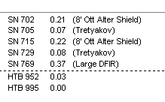
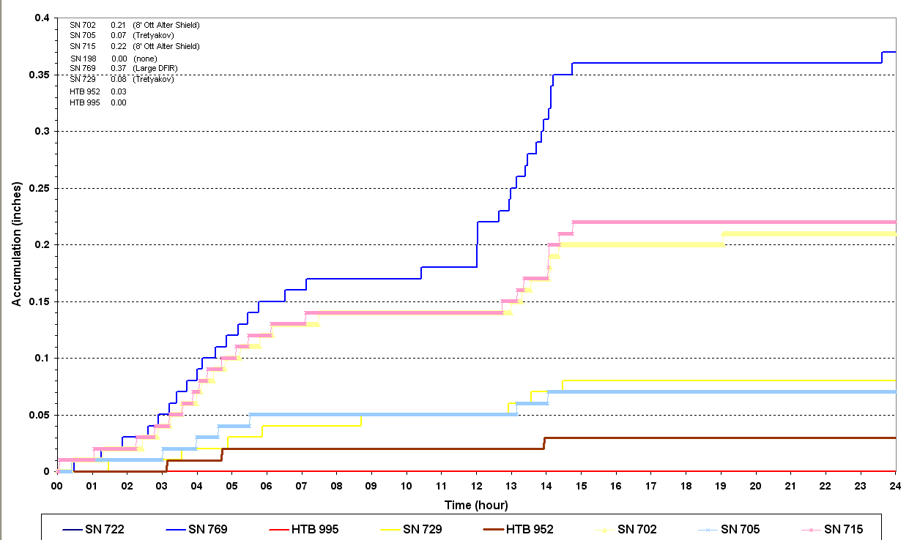

By the end of the event there was a 0.34-inch difference between the highest and lowest AWPAG precipitation totals. Both sensors equipped with the OTT ATDD style Alter Shield, as well as the AWPAG inside the Large DFIR, caught more precipitation than the manual gauges and ventured above the upper limit of the specified tolerance zone. Overall, the bulk of the precipitation fell on the 21st. The majority of the differences in catch between sensors can also be seen when the winds were highest (midday on the 21st). Overall, the AWPAGs equipped with the OTT ATDD style Alter Shields caught more precipitation than the manual gauges during high wind conditions. Additionally, these shields did not experience any physical failures or damage caused by the wind.

8.0 CONCLUSIONS

The winter test results gathered thus far have shown that the new OTT ATDD style Alter Shield outperformed all of the other gauges in Johnstown. Not only did both AWPAGs equipped with this shield pass specification in 100% of the events when excluding the upper bound of the specification, but they also proved to be effective in 91.7% of hourly measurements as well.

Data from the Johnstown site demonstrates that the new OTT ATDD style Alter Shield will measure closer to “ground truth” precipitation when compared to the 8-inch manual gauges. At Johnstown, the AWPAG gauge protected by the OTT ATDD style Alter Shield caught about 40% more precipitation than the 8-inch manual buckets. Testing in Johnstown also continues to support that all AWPAGs equipped with firmware version 3.61 are compliant with the specification.

It can be concluded that the high winds that occurred in the second and fourth analyzed events at Johnstown had an impact on the AWPAG data. Three of the five gauges failed to meet the event requirements because of over reporting; sensors #702 (OTT ATDD Alter) and #715 (OTT ATDD Alter) were the gauges that failed to meet the specification. It can also be determined that when the upper bound of the specification is removed, the AWPAGs fitted with OTT ATDD style Alter Shield are compliant with the specification.

9.0 REFERENCES
1. Final Report for Winter Test of Production All-Weather Precipitation Accumulation Gauge (AWPAG) - Nov. 2006 – Apr. 2007
2. Dover, J. and Winans, L.J., Evaluation of Windshields for use in the Automated Surface Observing System (ASOS); 6th Symposium on Integrated Observing Systems, 14-17 January 2002, Orlando, FL P.6.4.
3. Goodison, B.E., Louie, P.Y.T., and Yang, D., WMO Solid Precipitation Measurement Intercomparison, 1998.
4. Greeney, Chris, Final Report for Production AWPAGs 2005-2006, SAIC/NWS, 2006.
5. Winans, L, 2003: Test Report for Ott Pre-Production AWPAGs, November, 2002 - April, 2003. Science Applications International Corp.
6. Greeney, Christopher M., M.D. Gifford and M.L. Salyards, Winter Test of Production All Weather Precipitation Accumulation Gauge for ASOS 2003-2004, Ninth Symposium on Integrated Observing and Assimilation Systems for the Atmosphere, Oceans, and Land Surface, Jan -14, 2005, P8.3.
7. Final Report for Production AWPAGs, November, 2004 - April, 2005
8. Wade, C., and J. Cole, 2001, Final Report to CRN Management on the Snow Gauge and Windshield Evaluation Studies Conducted at NCAR from January to April 2001, NCAR Research Applications Program (RAP), 17 July 2001.
9. Development of the All-Weather Precipitation Accumulation Gauge Transfer Function for ASOS - Jennifer M. Dover, Joseph V. Fiore Jr., Science Applications International Corporation Sterling, VA 20166

APPENDIX A - FIRMWARE VERSION DESCRIPTION

Firmware Version | Test Dates  Sterling, Virginia | Test Dates  Johnstown, Pennsylvania | Comments
3.55 | 4/29/03 - 8/26/03 | 5/8/03 - 8/27/03 | under-catch correction
3.58 | 8/26/03 – 11/18/05 | 8/27/03 – 11/18/05,  &  2/1/07 – 5/14/08 | temperature compensation / precipitation threshold improvements
3.59 | 11/17/05 – 1/29/07 | 11/18/05 – 2/1/07 | user alterable low temperature orifice heater cut-off
3.60 | 2/25/08 – 5/2/08 | N/A | orifice heater controller improvements
3.61 | 5/2/08 - present | 5/14/08 - present | fix for TC value errors

APPENDIX B – WEATHER SUMMARY, JOHNSTOWN EVENTS

 | Reported Weather Conditions | Obscurations | Wind Speeds | Wind Gusts  Max.
11/17-11/18/2008 | -SN | FG | 5-23 mph | 30 mph
11/20-11/21/2008 | -SN | BLSN | 9-27 mph | 35 mph
11/25-11/26/2008 | -SN, -SG | BLSN | 8-23 mph | 34 mph
12/21/2008 | -FZDZ, -SN, SN, -PL | -- | 6-28 mph | 46 mph

APPENDIX C JOHNSTOWN, PENNSYLVANIA TEST BED
